In this case, there is no need for XML at all. We do all the configuration by plain old java code. Only difference is that we implement the **AnnotationConfigApplicationContext** implementation of ApplicationContext.

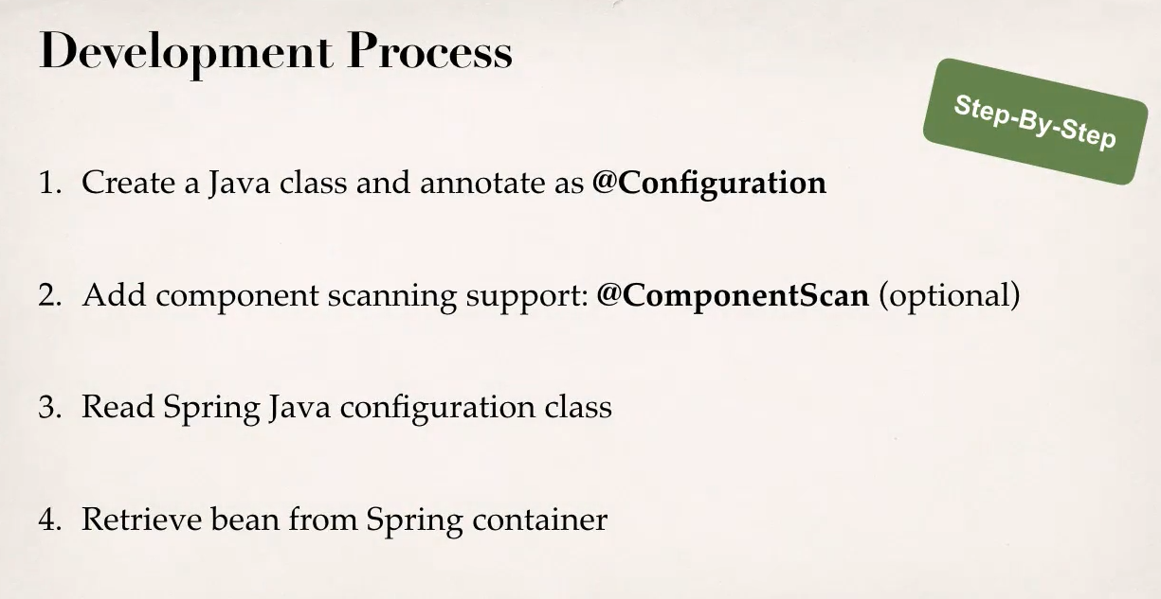

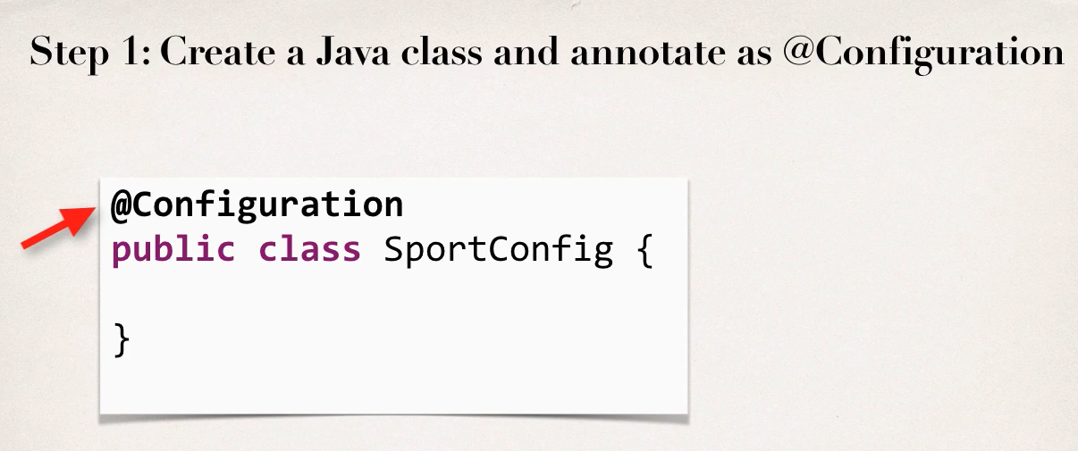

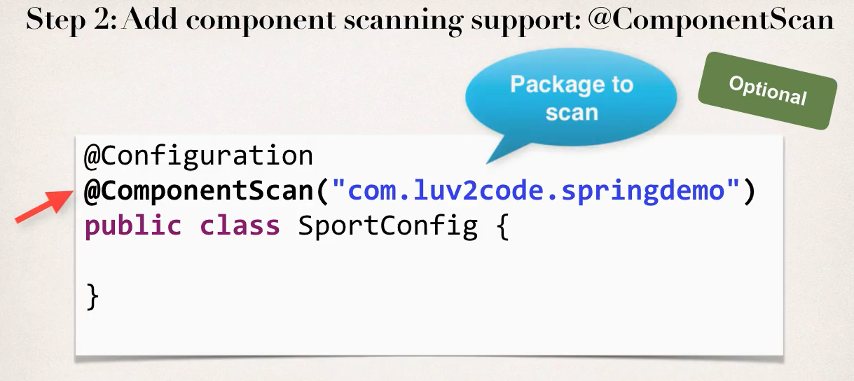

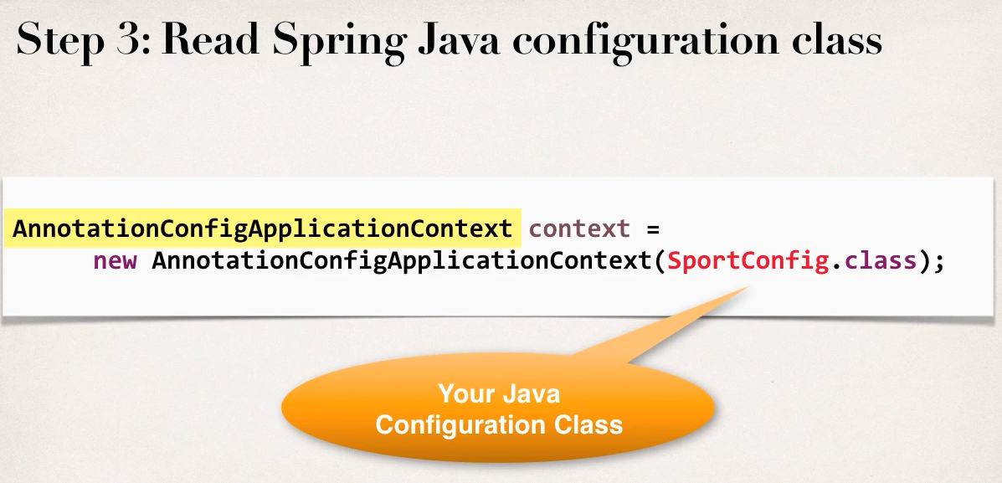

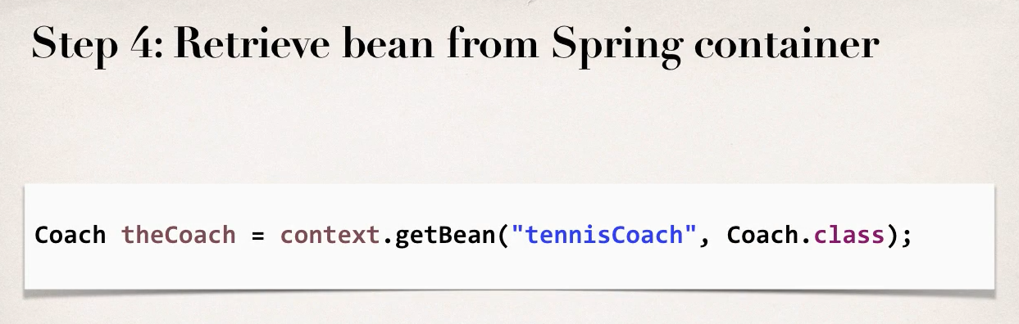

**Defining Beans without any Annotations:** Using the Java class configuration, we can define beans without any annotations. It doesn’t do any component scan since we are configuring our beans in the class itself.

* **IMPORTANT: The method name will be the actual bean id.**

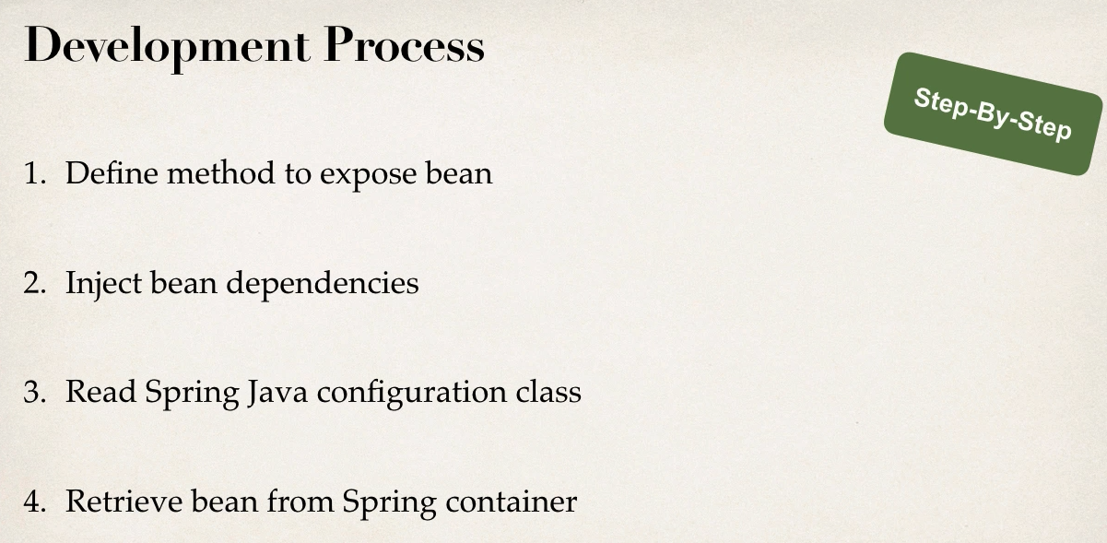

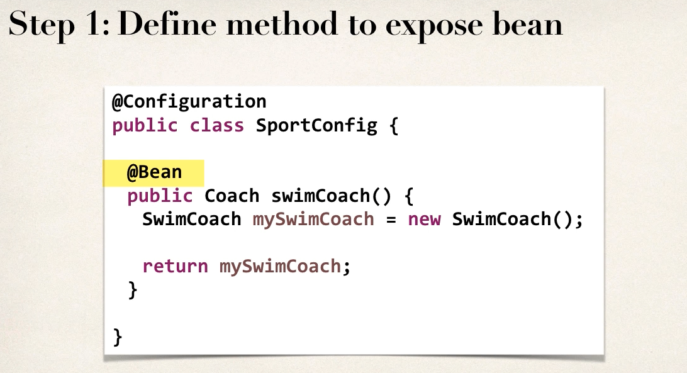 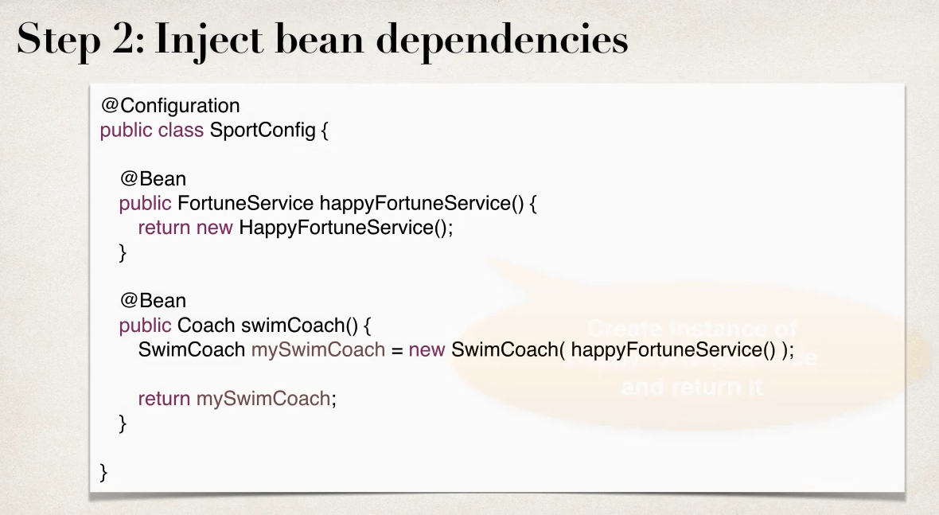

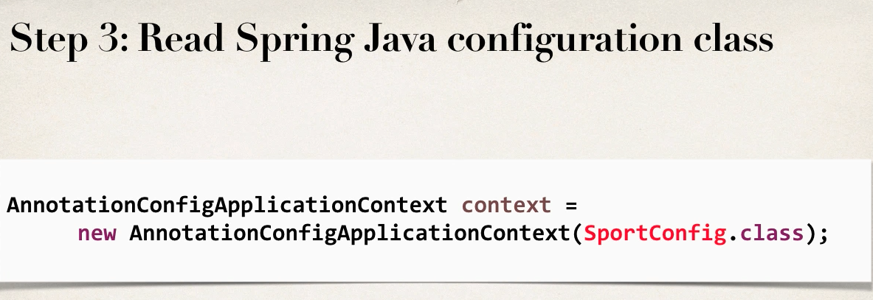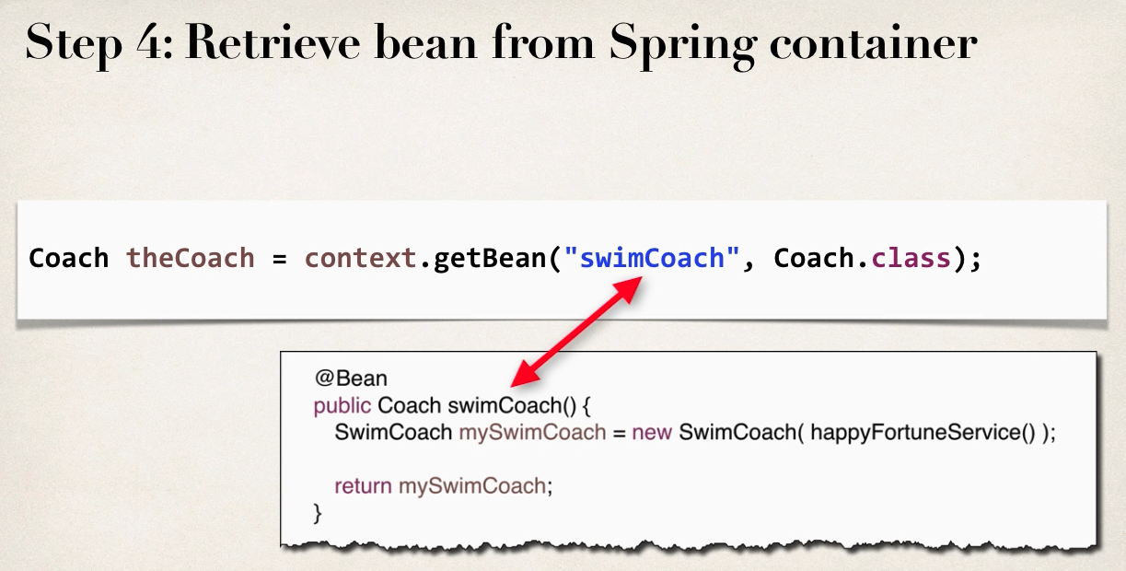

**Injective values from a properties file:**

Similar to how we injected values from property file in the xml configuration, here we can do same too. Below is the example process.

